ASSIGNMENT 7_5
V . Harika
2303a510i0
Batch : 30
Task 1 (Mutable Default Argument – Function Bug)
Task: Analyze given code where a mutable default argument causes unexpected behavior. Use AI to fix it.
Code:
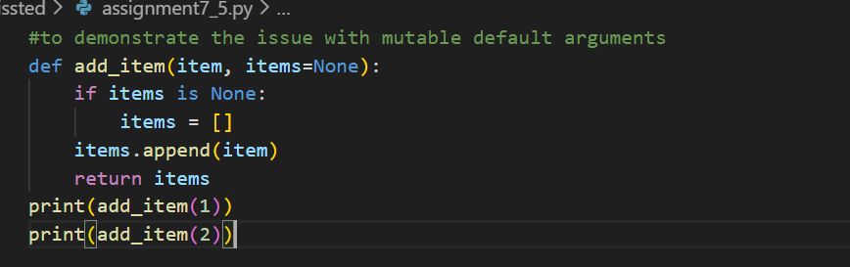
Output:
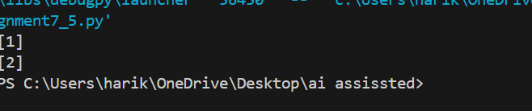
Justification:
• Using a mutable default like causes all function calls to share the same list.
• This leads to unexpected accumulation of items across calls.
• Fixing with ensures each call gets a fresh list.
Task 2 (Floating-Point Precision Error)
Task: Analyze given code where floating-point comparison fails. Use AI to correct with tolerance.
Code:
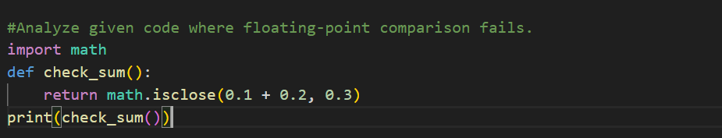
Output:
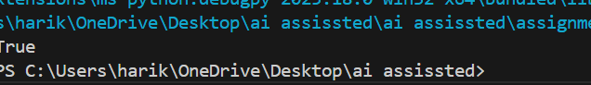
Justification:
- Floating-point numbers cannot represent certain decimals exactly.
- Direct equality (==) fails due to rounding errors.
- Using a tolerance (abs(diff) < epsilon) ensures reliable comparison.
Task 3 (Recursion Error – Missing Base Case)
Task: Analyze given code where recursion runs infinitely due to missing base case.
Code: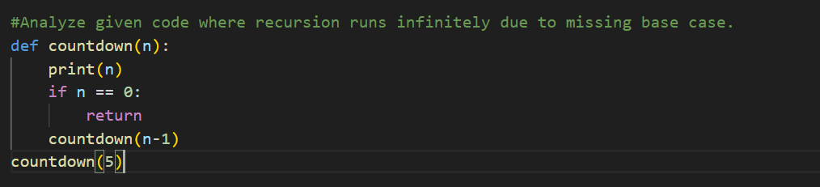
Output:
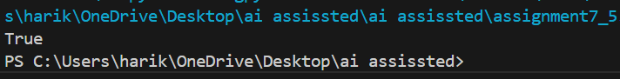
Justification:
- Without a base case, recursion continues infinitely.
- A stopping condition prevents stack overflow.
- Adding if n <= 0 ensures recursion halts properly.
Task 4 (Dictionary Key Error)
Task: Analyze given code where a missing dictionary key causes error.
Code:
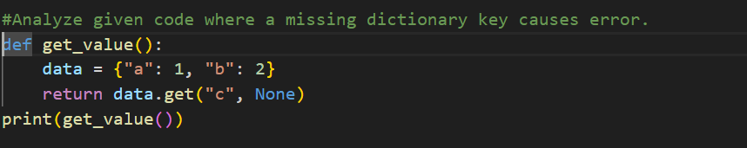
Output:
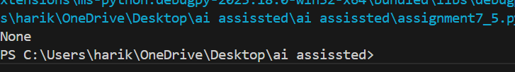
Justification:
      - Accessing a non-existent key raises KeyError.
- get() allows safe retrieval with a default value.
- This prevents crashes and provides controlled output.
Task 5 (Infinite Loop – Wrong Condition)
Task: Analyze given code where loop never ends. Use AI to detect and fix it.
Code:
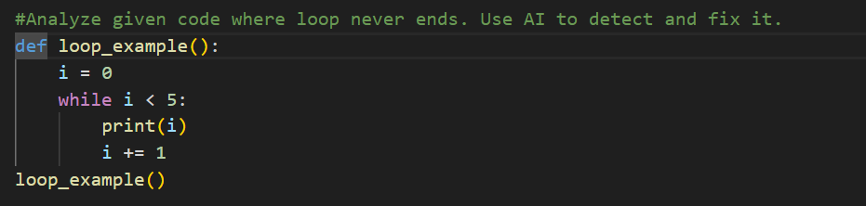
Output:
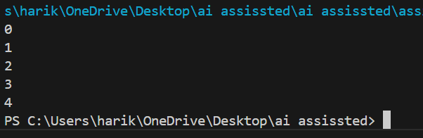
Justification:
The loop variable i never changes, so condition stays true.
- Adding i += 1 ensures progress toward termination.
- This prevents infinite execution
Task 6 (Unpacking Error – Wrong Variables)
Task: Analyze given code where tuple unpacking fails. Use AI to fix it.
Code:
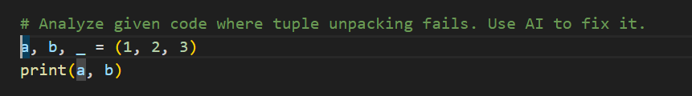
Output:
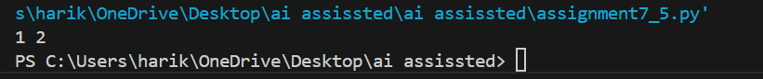
Tuple has more values than variables.
- Python requires exact matching in unpacking.
- Using _ or *rest handles extra values safely.

Task 7 (Mixed Indentation – Tabs vs Spaces)
Task: Analyze given code where mixed indentation breaks execution.
Code:
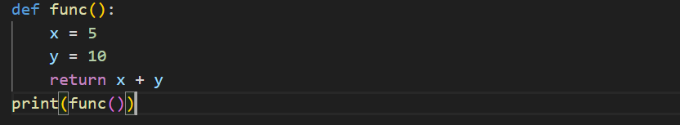
Output:
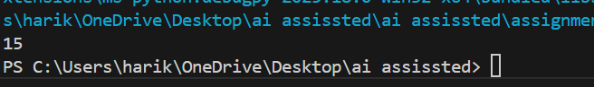
Justification:
Mixing tabs and spaces breaks Python’s indentation rules.
- Consistent indentation ensures readability and execution.
- Fixing alignment avoids Indentation Error.
Task 8 (Import Error – Wrong Module Usage.
Task: Analyze given code with incorrect import. Use AI to fix.
Code & output:
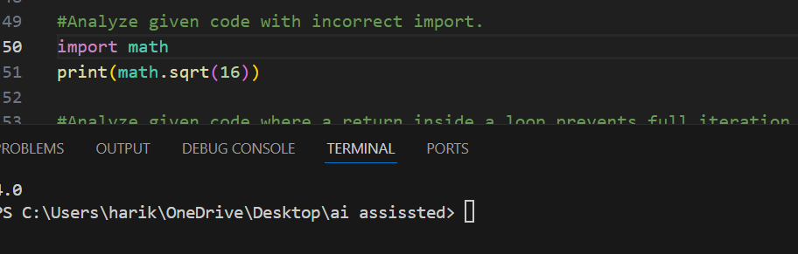
Justification:
Python module is math, not maths.
- Wrong import name causes ModuleNotFoundError.
- Correct spelling resolves the issue.
Task 9 (Unreachable Code – Return Inside Loop)
Task: Analyze given code where a return inside a loop prevents full iteration.
Code & output:

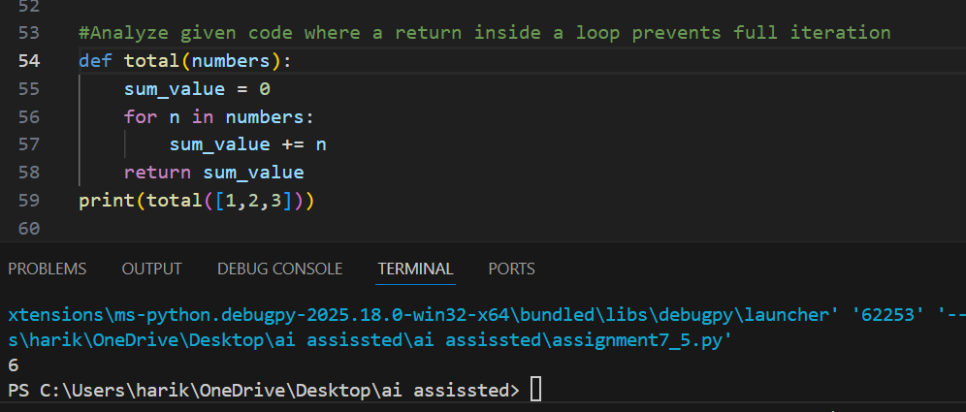
Justification:
return inside loop exits on first iteration.
- This prevents full processing of all elements.
- Accumulating values and returning after loop ensures correctness.
Task 10 (Name Error – Undefined Variable)
Task: Analyze given code where a variable is used before being defined.
Code & Output:
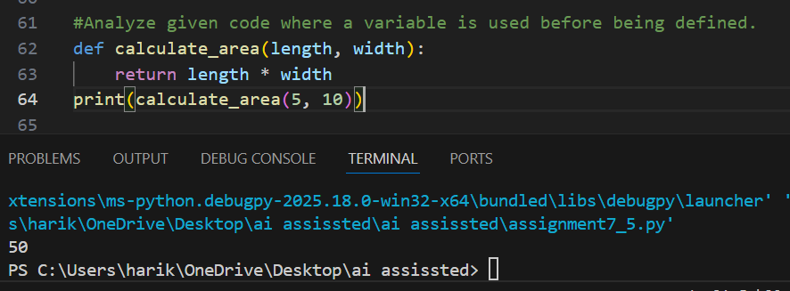
Justification:
Variables length and width are undefined.
- Using them without definition raises NameError.
- Passing them as parameters makes function reusable and correct.
Task 11 (Type Error – Mixing Data Types Incorrectly)
Task: Analyze given code where integers and strings are added incorrectly.
Code & Output:
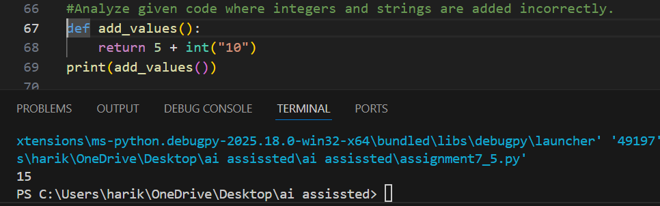
Justification:
Python does not allow adding integers and strings directly.
- Explicit conversion (int() or str()) resolves mismatch.
- This ensures valid arithmetic or concatenation.
Task 12 (Type Error – String + List Concatenation)
Task: Analyze code where a string is incorrectly added to a list.
Code & Output:
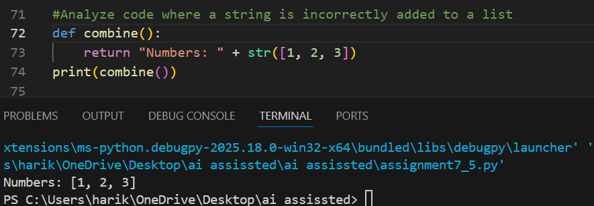
Justification:
Strings cannot be concatenated with lists directly.
- Conversion (str(list)) or joining elements fixes type mismatch.
- This allows meaningful output without error.

Task 13 (Type Error – Multiplying String by Float)
Task: Detect and fix code where a string is multiplied by a float.
Code & Output:
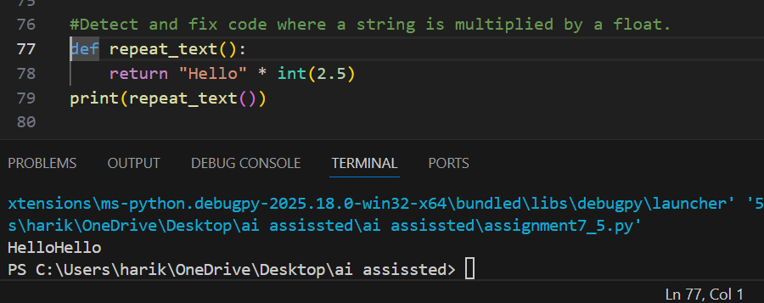
Justification:
Strings can only be multiplied by integers.
- Float multiplication is invalid.
- Converting float to int ensures valid repetition

Task 14 (Type Error – Adding None to Integer)
Task: Analyze code where None is added to an integer.
Code & Output:
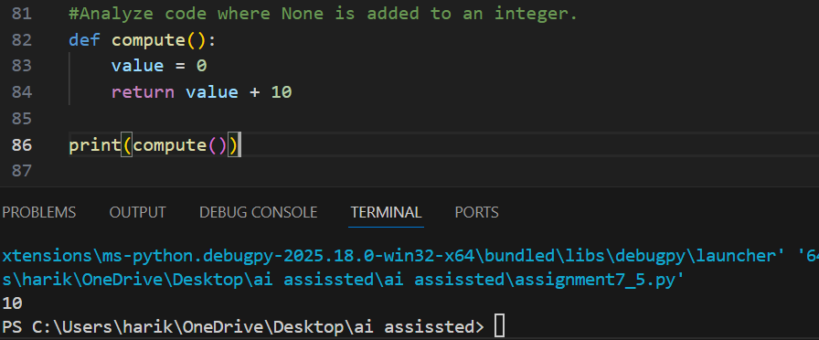
Justification:
None represents absence of value, not a number.
- Adding None to integer raises TypeError.
- Assigning a default numeric value resolves the issue

Task 15 (Type Error – Input Treated as String Instead of Number)
Task: Fix code where user input is not converted properly.
Code & Output:
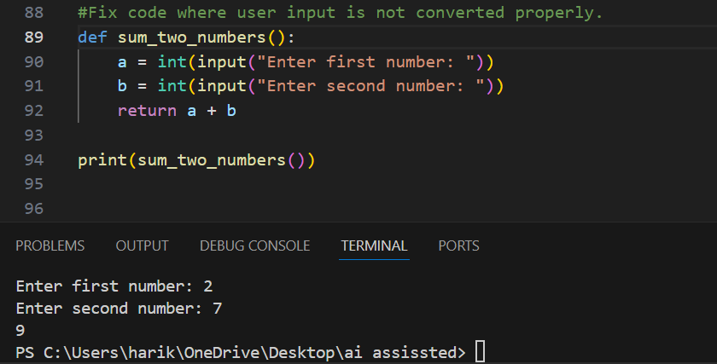
Justification:
input() always returns a string in Python.
- Adding strings results in concatenation, not arithmetic.
- Converting with int() ensures numeric addition.

